Atoms and Elements Notes

Lesson 1

Vocab: Nucleus, molecule, proton, neutron, electron, element, atom, periodic table, compound

Picture of Carbon Atom
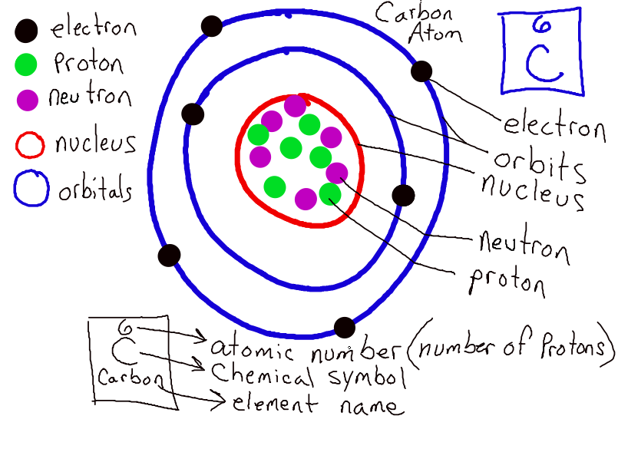

Atomic Theory: all matter is made of tiny particles called atoms
(John Dalton)

Atomic Number: the number of protons in an atom

*** Elements are classified or grouped by their properties***

Insulator: a substance that doesn’t conduct heat or electricity
Ex.) glass, plastics, rubber

Alloy: a mixture made of two or more metals
Ex.) Bronze, steel, brass
Properties of Metals
- Conducts Heat: means substance can transfer heat. Metals get hot when touching a heat source.
- Conducts Electricity: means substance can transfer electricity. Electricity can pass through it.
- Luster: Shininess
- Malleable: can be hammered or rolled into sheets
- Ductile: can be formed into wires

Lesson 2

Vocab: periodic table, compound

*Dmitri Mendeleev: a scientist who arranged elements on the periodic table according to their atomic masses. (This arrangement was later changed)*

*Modern Periodic Table is arranged according to the elements’ atomic number (number of protons) and by properties of the elements. (Metals are on the left, Metalloids are in the middle, Non-metals are on the right.)*

*Chemical Formula: tells us which elements are combined and how many elements of each.*

Ex.) H₂0= 2 atoms of Hydrogen and 1 atom of Oxygen (Water)

Ex.) C₆H₁₂O₆= 6 atoms of Carbon, 12 atoms of Hydrogen, and 6 atoms of Oxygen (Glucose-sugar)

