Ch. 12
The American Revolution

for more info:
http://americanrevwar.homestead.com/files/INDEX2.HTM

Lesson 1: The Declaration of Independence

Vocabulary: Second Continental Congress, Continental Army, traitor
Declaration of Independence
People: Thomas Paine, William Howe, Henry Knox, Thomas Jefferson,
John Locke

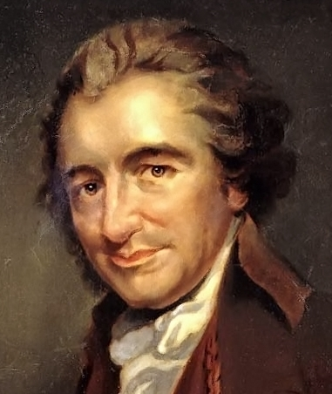
Common Sense
- A pamphlet written by Thomas Paine to explain to the colonists things that the British were doing to the colonists that were unfair
- Written so most colonists could read and understand it
- The first work that asked for independence from Great Britain
- Famous quote from Thomas Paine: “Tis time to part.”

The British Leave Boston
- When the British would not leave Boston, Henry Knox was sent by George Washington to Fort Ticonderoga and dragged cannons to Boston
- When British woke up they were surrounded by cannons and surrendered
- Colonists had taken Boston back

Second Continental Congress
- Met in Philadelphia
- Decided to form the Continental Army to protect colonies from future attacks
- Commander in chief to lead the Army was George Washington
- Post office was started so the colonies could share news
- Benjamin Franklin was the postmaster general
- Began to form peace with Native Americans
- Asked foreign countries for support against the British

A Last Chance for Peace
- July 1775-Congress tried to make peace with Britain one last time
- Sent the “Olive Branch Petition” to King George
- Olive branch is a symbol of peace
- The petition assured that the Americans would be loyal to the British and asked to end the fighting

Declaring Independence
- King refused to read the Olive Branch Petition so the colonists responded by writing a formal Declaration of Independence
- Thomas Jefferson drafted the document-he was 33

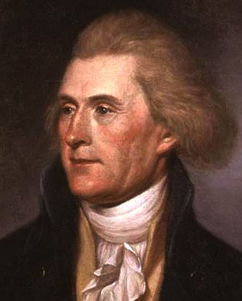
Writing the Declaration
- Jefferson was prepared from reading Thomas Paine’s Common Sense, studying the ideas of John Locke, and hearing Patrick Henry speak
- Jefferson wrote the draft in two days!
- Few changes were made and then it was shown to Congress
- It was approved July 4, 1776

Who signed the Declaration of Independence first?

What are the three unalienable rights?

Re-read why it matters and list 3 reasons why the Declaration of Independence was so important
Lesson 2: The Continental Army

Vocabulary: mercenary, Loyalist, Patriot
People: Nathan Hale, Martha Washington, John Burgoyne, Thaddeus
Kosciuszko, Marquis de Lafayette, Friedrich von Steuben

*Nathan Hale- “I only regret that I have but one life to lose for my country.”

The Continental Army
- By December Washington only had 3,000 men left
- They were poorly equipped
- They were running low on food, supplies, and uniforms
- Many looked forward to when their time in the army was up

Red Coats and Continentals
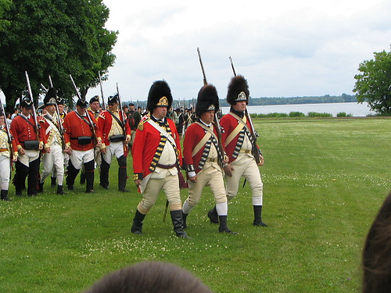
- The strengths of the British
  - The British soldiers (Redcoats) had nice uniforms
  - The Redcoats were well-trained
  - The Redcoats had the strongest navy in the world
  - Had money to buy mercenaries (Hessians)
- The strengths of the Americans
  - They knew the land well
  - Their supplies and troops did not have to be shipped over the Atlantic Ocean
  - Fighting for their freedom (fighting for a purpose)

Patriots and Loyalist
- 1/3 of Americans were Loyalist-they were against the war and loyal to Britain
- 1/3 of Americans were Patriots- they supported the fight for independence
- 1/3 did not take any sides

Victory in Trenton
- Washington knew that General Howe was resting during the Winter months
- Washington planned a surprise attack on the Hessians in Trenton
- The Hessians quickly surrendered (Dec. 1776)

The Continental Army and Slavery
- Many African Americans fought in the war with the Patriots.
- Washington decided not to let any more African Americans join the army, but he later changed his mind
- He now promised the African Americans, that were willing to fight, their freedom after the war was over
- Washington was one of the first to free his slaves when the war was over
- Pennsylvania adopted a plan to abolish slavery in 1780.

*Turning point- John Burgoyne (a British general) wanted to capture the Hudson River valley and cut off New York and New England from the rest of the colonies

The Battle of Saratoga
- The Colonial forces slowed down the British on their way to Albany
- Thaddeus Kosciuszko was able to gather enough troops to stop the British
- This bought the colonists time so when British reached Saratoga they were vastly outnumbered and surrendered after two months of fighting
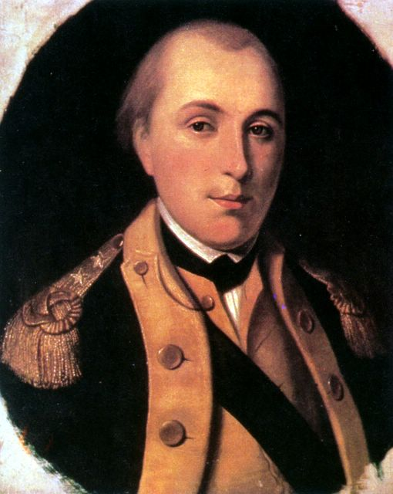
Marquis de Lafayette
- A French man whose father was killed by the British
- He wanted to fight for the Americans
- He volunteered to serve in the army and bought all his own supplies
- He became like a son to George Washington

The Winter at Valley Forge
- Philadelphia was captured by General Howe
- Washington and his troops set up at Valley Forge, right outside of Philadelphia
- Supplies were low
- Many soldiers left and went home
- Many had no shoes
- At least 2,500 died
- Friedrich von Steuben helped train the army and turned them into a powerful army

Who joined the war in 1778?

What did they send?

Video on Battles of the American Revolution (Unitedstreaming)

Quiz on Lessons 1 and 2

Lesson 3: Independence at Last

Vocabulary: Treaty of Paris

People: George Rogers Clark, John Paul Jones, Benedict Arnold, Mary Ludwig Hays, Haym Salomon, Francis Marion, Nathanael Greene, Charles Cornwallis, Bernardo de Galvez, James Armistead, Joseph Brant

Patriots Fight in the West
- George Rogers Clark
  - Surveyor in Kentucky
  - His goal was to drive the British out of the Ohio River Valley
  - Fort Vincennes was taken over by Clark and then retaken by the British
  - Clark set out in the winter with his men to retake the fort again
  - Clark and his men surprised the British by screaming and yelling making it seem like there were more men then there really were
  - Americans now controlled the Ohio River Valley
  - Clark was known as the “Washington of the West”

Patriots Fight on the Seas
- John Paul Jones
  - American Sea Captain
  - Jones’s battleship, the Bonhomme Richard faced the British battleship Serapis
  - The British ruined the Bonhomme Richard
  - Jones did not surrender saying “I have not yet begun to fight”
  - After three hours of fighting, the Serapis surrendered
  - One of Jones men called the battle “the most bloody hardest battles ever fought between two ships”

Benedict Arnold Turns Traitor
- He was a Patriot
- Married a woman from a Loyalist family
- Was in debt
- Washington gave him command of West Point
- Arnold was going to tell the British West Point’s defenses in exchange for money
- Americans found out and he escaped and became a British officer
- The British never fully trusted him

Supporting the Soldiers
- Many people helped fight against the British
  - Mary Ludwig Hays became known as “Molly Pitcher” because she brought pitchers of water to soldiers during battle
  - Some women disguised themselves as men and fought (Deborah Sampson)
  - Others served as spies (Dicey Langston)
  - Haym Solomon was a spy for the Patriots and he also raised money for the Continental Army

Patriots Fight in the South
- Francis Marion had a small amount of soldiers
- He fought quickly and then went back into the Carolina swamps
- He became known as “Swamp Fox”
- Nathanael Greene’s approach was “We fight, we get beat, we rise, we fight again”
- Cornwallis got tired of chasing Greene around so he headed to Virginia

The Spanish Help the Patriots
- Spain joined the war and fought with the Patriots
- Bernardo de Galvez
    - Governor of Spanish Louisiana
    - Ended trade with British
    - Opened up New Orleans port to American ships
    - Sent money and supplies to George Rogers Clark
    - Commander of Spain’s troops

The Battle of Guilford Court House
- British marched its men shoulder to shoulder
- Cornwallis lost ¼ of his men during this battle because of this strategy
- British won only because Nathanael Greene and Patriots retreated
- Cornwallis left the Carolinas with its forces greatly weakened and in need of supplies

Victory at Yorktown
- Cornwallis thought James Armistead was spying on the Americans, BUT he was spying on the British and told Lafayette of Cornwallis’s plans
- Armistead also gave false information to the British about the Americans
- Cornwallis thought Washington was going to attack New York but Washington really attacked Yorktown with the help of the French and 17,000 troops
- Cornwallis surrendered when he realized he was outnumbered
- This was the last major battle of the Revolution
- King George still wanted to fight but the British House of Commons was tired of fighting and wanted to make peace
- The Treaty of Paris of 1783 was signed and Britain recognized the United States as being independent

* What land became part of the United States after peace was made?

* Who left the United States for good after the war?

* Where did they move to?

* John Adams said there were “two revolutions”, what did he mean when he said this?
