Chapter 7
Early European Settlements of North America

Lesson 1: Roanoke Colony (Lost Colony)

Vocab: charter, armada, Queen Elizabeth I, Sir Walter Raleigh, John White, King Phillip II

*1st English Settlements
-Roanoke Colony- colony was founded by Sir Walter Raleigh
*First attempt: colonists ran out of supplies and due to hunger and hardships, they returned to England. They angered the Native Americans by killing a chief.

*Second attempt: about 100 colonists came back to the Americas led by John White. He and some crew members needed to return to England for supplies.
When he arrived back at England, England was at war with Spain (Spanish Armada). He wasn’t able to return to the colony for 3 years. When he did, everyone was gone. Only clue: the word CROATOAN was carved on a tree. We don’t know what happened to the people.

*1588- Spanish Armada- war between Spain and England. The king of Spain was angry at the English for attacking Spanish ships loaded with goods from Spanish colonies in the Americas. He sent an armada of ships to attack the English. Smaller English ships won the battle. This victory gave England confidence to continue to try and establish a colony in the Americas.

Lesson 2: Northwest Passage

Vocab: Northwest Passage, profit, Henry Hudson, John Cabot, Giovanni da Verrazano, Jacques Cartier, Samuel de Champlain
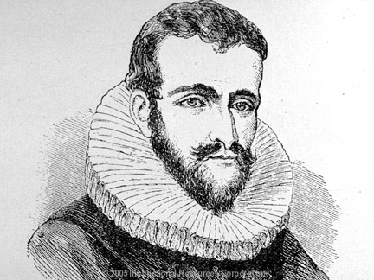
*English, French, Swedish, and Dutch explorers were searching for a Northwest Passage (a water route through North America to Asia).

Henry Hudson→

*Dutch East India Company- merchants who paid for expeditions in exchange for profits that the explorers made. Henry Hudson sailed for the Dutch East India Company.

*Hudson’s ship: Half Moon

*Hudson didn’t find the Northwest Passage, but he did establish trade between the Dutch and two Native American tribes (Mannahata and the Lenni Lenape)

*Hudson was abandoned (set adrift on a small boat) by his crew on his final voyage to America.

Lesson 3
Vocab and People: stock, cash crop, indentured servants, House of Burgesses, Chief Powhatan, John Smith, Pocahontas, John Rolfe, Openchancanough

*Jamestown= John Smith (leader)
*John Rolfe married Pocahontas
*John Rolfe grew tobacco as a cash crop
*Native American Tribe was Powhatan (leader was Chief Powhatan)
*1st form of self government- Virginia House of Burgesses

Lesson 4
Vocab and people: Mayflower Compact, sachem, Massasoit, Squanto, Samoset, William Bradford, Miles Standish

*Wampanoag: main Native American tribe in the Plymouth area.

*Three Native Americans who helped the Pilgrims survive:
-Massasoit (Wampanoag Sachem), Squanto, Samoset

*What did Squanto teach the Pilgrims?
-How to fertilize crops with fish
-How to hunt and trap animals for food
-Shared his knowledge of the woodlands

*Pilgrims left England for Religious Freedom

*Pilgrims came across the Atlantic on the Mayflower

*Leader of the Pilgrims was William Bradford

*Male Pilgrims signed the Mayflower Compact (saying they would obey just and equal laws)

*Mayflower Compact is another form of self government (the other- Virginia House of Burgesses)

*The Pilgrims celebrated the “First Thanksgiving” with the Wampanoag. It was a celebration of their good harvest.

