Chapter 8
The English Establish 13 Colonies
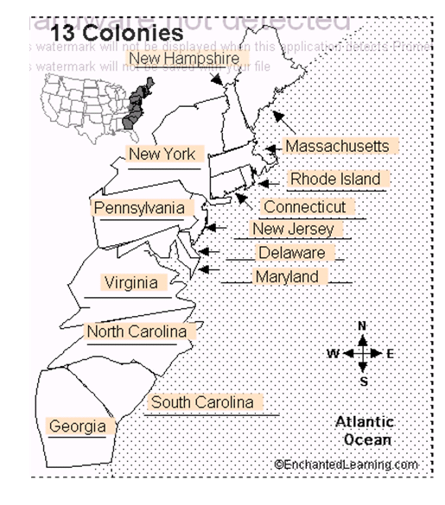

Lesson 1: The New England Colonies

Vocab: covenant, tolerate
People: King Charles I, John Winthrop, Roger Williams, Anne Hutchinson, Thomas Hooker, Metacomet

Colonies: Massachusetts, Rhode Island, Connecticut, New Hampshire

*Puritans settled in Massachusetts Bay Colony in 1630*

*Puritans came to the colonies seeking Religious Freedom*

*John Winthrop was the leader of the Puritans*

*Puritans felt education was important so that all children could learn to read the Bible*.
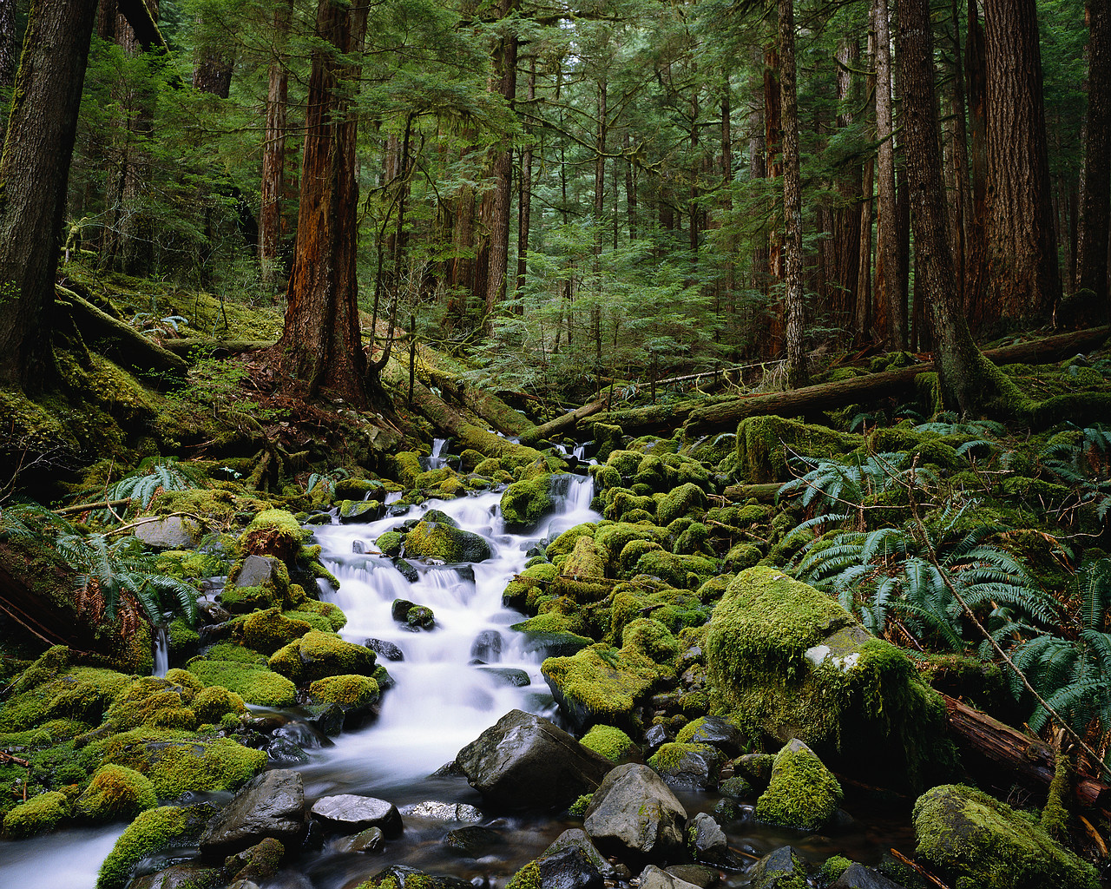
Natural Resources:
Bad soil= thin and rocky (not that good for farming)

Plentiful Forests= used wood for lumber, hunted animals

Charles River and Atlantic Ocean= good for fishing

***Relationship with Native Americans begins to become strained because colonists continue to take more land***

***In 1620, Pilgrims came with about 100 people. By 1640, the population of the Massachusetts colony rose to over 20,000.***
Puritans with different views:

*Roger Williams: believed the Puritans should tolerate other religions. He was forced to leave Massachusetts. He founded the settlement of Providence in Rhode Island.

*Anne Hutchinson: believed people should pray directly to God rather than depend on church teachings. She was forced to leave Massachusetts and started a settlement in Portsmouth, Rhode Island.

*Thomas Hooker: believed each church should be run independently. He along with followers founded the colony of Connecticut.

Lesson 2: Middle Colonies

Vocab: conestoga
People: King Charles II, William Penn

Middle Colonies: New York, New Jersey, Pennsylvania, Delaware

*William Penn began a colony and called it Pennsylvania*
*Penn and his followers were Quakers*
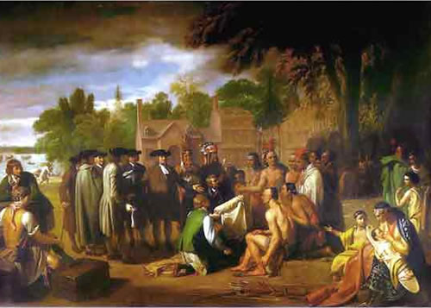
*Quakers called themselves the “Society of Friends” because they believed everyone should be treated fairly*

*Relations between the Quakers and the Lenni Lenape were good because William Penn paid them for their land and agreed to treat them fairly.

*New York Harbor was one of the busiest ports in all of the colonies.

*The Middle colonies became a melting pot of people from all over Europe. There were Germans, Dutch, Jewish people from Portugal, Scots-Irish, as well as Africans

Natural Resources:
*Rich soil= good for farming and growing crops (became the main food growing region in all of the colonies.
*Fresh waterways (lakes and rivers)
*Plentiful woods

Lesson 3: Southern Colonies

Vocab: proprietor, debtor, indigo
People: Tomochichi, James Oglethorpe, King George II

Southern Colonies: Maryland, Virginia, North Carolina, South Carolina, Georgia

*Maryland was founded by Lord Baltimore. It became a place where Roman Catholics could practice their religion freely.*

*Smaller Creek villages banded together to form the Creek Confederacy. They did this to protect themselves from the settlers much like the Powhatan.*

*In 1663, the English established what became known as the colonies of North Carolina and South Carolina.*

*In 1732, James Oglethorpe was granted a charter to start the colony of Georgia, which was to be a colony for debtors and poor people. Later wealthy colonists began forcing people to work as slaves on large rice and indigo farms.*

*Oglethorpe received land from Chief Tomochichi for the settlement of Savannah, Georgia.*

Georgia serves 2 purposes:
- Protect English colonies from the Spanish and French
- Serve as a place for English debtors to live so English prisons aren’t overcrowded.

Natural Resources
Good Soil: farmers found the soil to be of good quality for growing crops such as corn, tobacco, rice, and indigo.
(*Tobacco, rice, and indigo were grown as cash crops.)
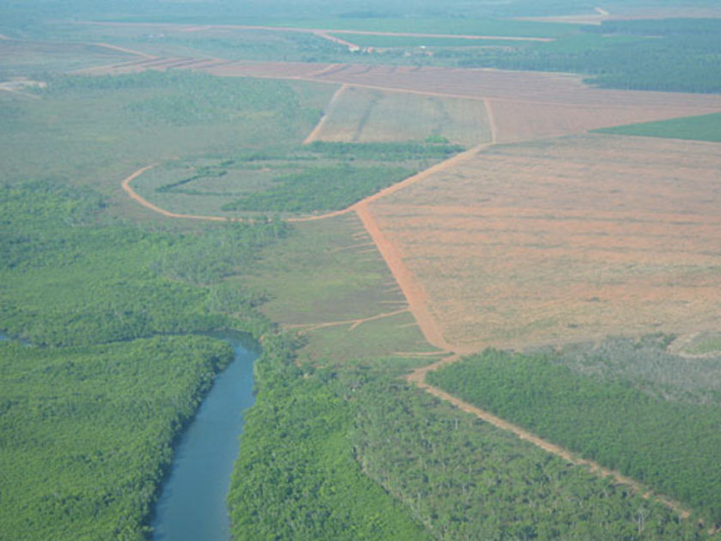
(*Long growing season also aided in growing crops in the south.)

Good water supply: helps with growing crops

