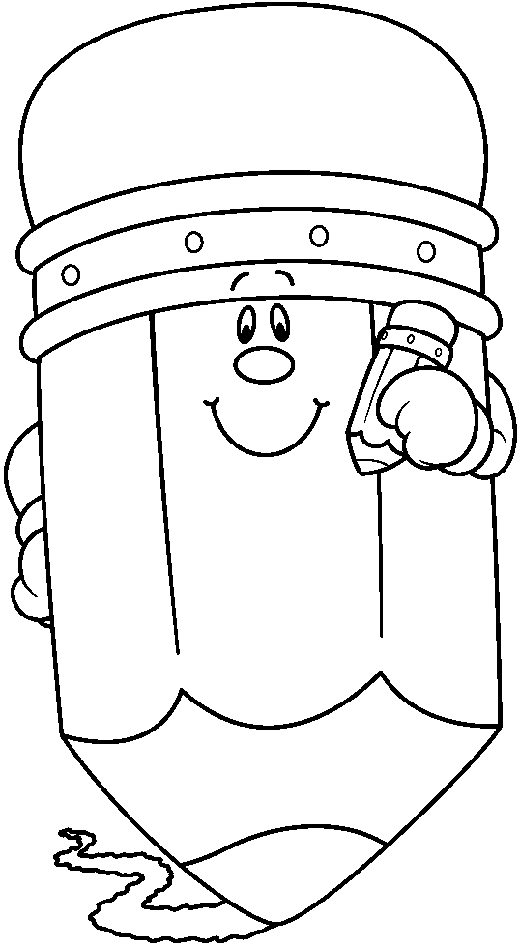
Getting Ready for Kindergarten
This checklist has been developed by the kindergarten teachers in the Hamburg Area School District. Please hang it on your refrigerator. Use the suggested activities to help your child prepare for kindergarten. When your child is able to successfully do a skill, allow him/her to put a sticker in the box in front of that skill. We urge you to enjoy these activities with your child as you prepare him/her for kindergarten! ☺
Sticker | Things your child should know before entering kindergarten
Recognize ten basic colors (red, yellow, blue, orange, green, purple, black, brown, white, pink)
- Expose your child to the colors using crayons.
- Search for colors in your home, on road signs, on cereal boxes, and on clothing.
Recognize four basic shapes (circle, triangle, square, rectangle)
- Identify shapes in your child’s environment. Take walks and point out shapes on buildings and road signs.
- Make shapes using Play-doh.
Spell, read, and write first name (with the first letter uppercase and all the rest lowercase)
- Use magnetic letters to spell your child’s first name on the refrigerator.
- Practice writing first name in pudding, sand, shaving cream, or using alphabet cereal.
- Practice printing first name on writing paper.
Sing the alphabet song
- Practice with your child at home, in the car, at the park, etc.
Point to and name the numbers 0 to 5 (when they are written out of order)
- Write the numbers using the materials listed above (pudding, etc.).
- Circle numbers in print (for example, in newspapers, magazines, and coupons).
Count 5 objects
- Practice counting various objects while in the car and at home (for ex., candy, toys, cars).

Sticker | Things your child should be exposed to before entering kindergarten
Identify the front and back of a book
- Read to your child every day.
Discriminate between pictures and words in a book
- As you read to your child daily, point to the words as you read them aloud.
Recognize rhyming words
- Read Dr. Seuss books and name the rhyming words. Think of other rhyming words.
Trace a simple object
- Have your child trace pictures in coloring books.
- Make cardboard tracers of hearts, circles, squares, etc. for your child to practice tracing.
Cut on a line
- Draw simple lines for your child to cut, reminding him/her to “Keep your car (scissors) on the road (line).”
Speak using appropriate-aged language
- Be a role model for your child as you speak. Baby talk is not “cute” anymore! Keep bad habits from forming by having your child repeat correct language.
Sit appropriately during a story
- Read to your child daily. Have him/her sit during your reading session (10 to 15 minutes, as this is the length of an average kindergarten lesson).
Play cooperatively
- Enroll your child in a social setting (for example, library activities, play groups, church functions). This will alleviate separation anxiety.
Identify and write all letters of the alphabet, including both uppercase and lowercase letters
- Practice naming letters on flash cards.
- Write the letters using a variety of materials (pudding, etc.).

Skills to help your child become more independent
Practice verbalizing personal information (first, middle, and last name; birthday; address; phone number)
Follow two-step directions
- Give silly two-step directions for your child to follow (for ex., “Quack like a duck and then hop on one foot.”).
Effectively blow nose

Tie shoes and button/zip clothing

Use appropriate bathroom skills (washing hands and wiping)

