Science Unit B: Chapter 2
Living Things Interact

Lesson 1: What are Ecosystems?

Vocab: individual, population, community, ecosystem, habitat, niche

Find out:

- About the parts of an ecosystem
- How the environment affects living organisms in an ecosystem

*Together, a community and its physical environment make up an ecosystem.

*Populations in a healthy ecosystem are dependent on one another for survival.
For example: different animals eat certain animals to keep those populations from getting too large.

*Interactions between plants and animals also help keep the balance of the carbon dioxide and oxygen in the atmosphere.
*Soil conditions, temperature, and rainfall determine what type and number of plants will grow in an area.

*The kinds and numbers of plants in an ecosystem determine what animals will live there.
*Populations of animals depend on the amount of available food or any other limited resource.

Population Density: the number of animals in a certain area

Lesson 2: How Energy is Transferred in an Ecosystem

Vocab: producer, consumer, food chain, decomposer, food web, energy pyramid

* Producers get the energy they need to make food from the sun, carbon dioxide, and water.

* Consumers get the energy they need by eating producers or other consumers.

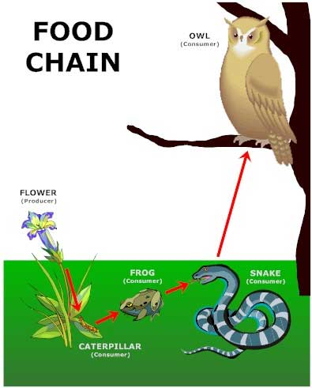
Food Web (made up of several food chains)
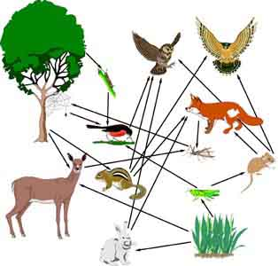

* Only 10% of the energy in a food chain is passed on to the next level, which means there are usually less organisms when you move further up the food chain.
Ex. Typically the number of wolves will be far less than the number of squirrels, rabbits, and other small animals living in a particular environment.
(Think about WHY that is?????)

Learn More:
- http://www.vtaide.com/png/foodchains.htm
- http://www.picadome.fcps.net/lab/currl/food_chain/default.htm
- http://www.ecokids.ca/pub/eco_info/topics/frogs/chain_reaction/index.cfm

Lesson 3: Ways in which Organisms Compete

Vocab: competition, symbiosis, instinct, learned behavior

Find Out:
- How organisms compete for and share resources
- What symbiosis is
- How instincts and learned behaviors help animals survive
*Animals compete with each other over limited resources in an ecosystem such as food.
Predators: animals that hunt other animals
Prey: animals that are hunted
Camouflage: animals change body color or blend in with their surroundings to hide from predators or prey

Adaptations: special characteristics that enables animals to survive and compete for resources.
Ex. Cheetahs are very fast; hyenas hunt in packs
*These adaptations enable these animals to compete for the same food.

*Many animals share the same resources.
Ex. Several animals may eat from the same tree, but at different heights. Giraffes eat from high branches, antelopes eat from middle branches, and rhinos eat from lower branches. They are all sharing the same food resource.

Ex. Many birds and small animals (squirrels) may share the same tree for food and shelter.

Mutualism: a relationship where both organisms benefit.
Ex. Cleaner fish and sharks- cleaner fish eat the food in sharks’ teeth. Cleaner fish get food, while the shark gets its teeth cleaned.

Instincts and Learned Behavior

*Behaviors for building shelters, migrating, finding mates, and hunting prey are usually instinctive.

*Learning how to hunt or what kind of nest to build are learned behaviors that animals learn from their parents.
Lesson 4: Extinction and Its Causes

Vocab: exotic, extinct, endangered, threatened

*Most declines in populations are caused by human activity.
Ex. Over hunting, introducing alien species, destruction of habitat (building roads, homes, etc.)

*Natural causes for population decline: floods, droughts, fires, volcanoes, etc. (these causes are usually temporary where as human activity is permanent)

*Biggest cause of extinction today is habitat destruction.

*Endangered Species Act: lists animals along with the size of their population. The Act sets up wildlife refuges to protect animals on the list.

??? Why were bald eagles and peregrine falcons in danger of becoming extinct???

Learn more about the Endangered Species Act: http://www.fws.gov/endangered/

