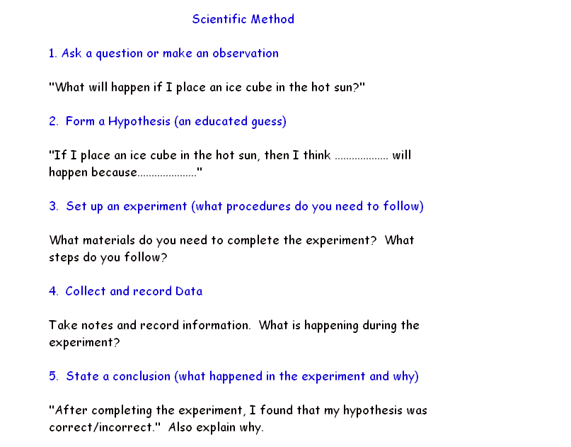
Morning Glory
Explanation: The Morning glory opens because the newspaper is made of wood fibers (plant cells) which absorb water. When the cells fill up, they expand causing the newspaper to open.

Magic Milk:
EXPLANATION: The detergent emulsifies (breaks up into smaller pieces) the fat in the milk. When this breaking-down occurs, it is possible to see the motion of the fat molecules because they are moving the food coloring molecules during this process.

Bubble Gum:
Explanation: As you chew the gum, you absorb the sugar in the gum. As a result the gum has less mass. (You gain mass by chewing gum!!! Maybe not a good idea if you’re on a diet)

