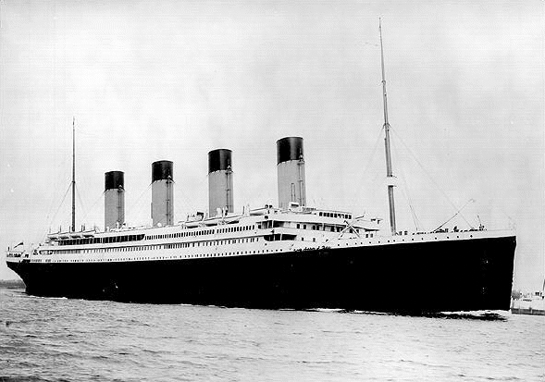
The Titanic
Disaster

The 'Unsinkable' Titanic
The first SOS signal in history failed to save 1,513 men, women and children

The sea was as smooth as a millpond and the sky brilliant with stars when Frederick Fleet, the look-out in the crow's nest, spotted the towering grey mountain of ice.

'Iceberg right ahead,' he shouted down his telephone to the bridge. And so began two hours and 40 minutes of disbelief, fear, and finally horror for the 2,300 passengers of the White Star liner- the 'unsinkable' Titanic. For that was all the time that it took, from the moment the iceberg was sighted, for the biggest and supposedly safest liner in the world to sink beneath the icy waters of the North Atlantic.

It was 11.40 p.m. on April 14, 1912, when the warning call came from the' crow's nest. Immediately, the huge vessel swung to port -but not soon enough. The Titanic scraped along the jagged side of the iceberg. On the bridge, officers congratulated themselves on a near-miss. But below the water line, the Atlantic Ocean poured in through a 300-foot gash in the ship's plates.

Task – Read the following sentences and decide whether they are true or false.

- On the night the Titanic sank, the weather was stormy and the sea was rough.
- The ship was carrying 2300 passengers.
- The ship was sailing in the South Atlantic Ocean when it hit the iceberg.
- Frederick Fleet in the crow’s nest spotted the iceberg and signalled to the bridge of the ship.
- The ship did not alter its course and sailed straight into the iceberg.
- The ship took 2 hours and 40 minute to sink.
- The collision with iceberg caused a 300-foot gash in the ship’s plates.
- The Titanic was thought to be “unsinkable”.

The Eyewitness

George Rowe was one of the quartermasters on the Titanic. This is how he described the crash:
“The first I knew or the disaster was when I felt a peculiar shiver run through the vessel.
It became icy cold and my breath froze in the air. Then I saw the iceberg -and I shall never
forget it. At first I thought we had hit a windjammer as I caught a glimpse of something sliding
past the ship on the starboard side. In the glare from the light of thousands of portholes,
the smooth surface looked just like wet canvas. I ran over to the side and realised that I was
looking at an iceberg. It was so big that it seemed to fill the sky. It was a giant among
icebergs and towered menacingly even above the bridge. For a few seconds I gazed at
it unbelievingly. It was just a few feet away and I felt I could have touched it. Then it was
gone - swallowed up in the blackness.”

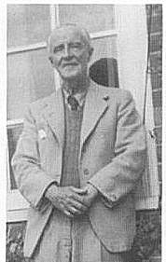
Even when the ship's master, Captain Ernest Smith, Commodore of the White Star fleet, realised that the hull of the world's wondership had been breached, he showed no signs of alarm. Alter all, the Titanic was 'unsinkable'. That had been the proud boast when the liner had left Southampton for New York four days earlier, at the start of her maiden voyage.

The ship's 850-foot-long hull had been made up of 14 watertight compartments. And the ship had a double bottom. It was the safest in the world. In fact, the Titanic could have remained afloat with all of her first four watertight compartments flooded. But the iceberg had torn through the first five - and, because or some strange quirk in the ship's design, Bulkhead Number Five did not stretch up as high into the ship as the others. With the first four compartments flooded, the liner's bows would dip, the water would flow over Bulkhead Number Five into the sixth compartment...then into the seventh and the eighth...And it would then simply be a matter of time...

Task
1. With a partner, write an explanation of how the Titanic flooded.

Who was to blame?

The myth of the Titanic's unsinkability was only one of an incredible combination of human errors, without which neither the liner nor the 1,513 lives need have been lost.

Why was the Titanic travelling so fast -22 knots - when a mass of icebergs had been reported in the area? Just before the crash, the liner was at 'full ahead', despite the fact that during that evening wireless signals had been received from other vessels including the Baltic, containing the information that she was heading straight into an icefield. The Baltic's message had been handed to George Ismay, the line's managing director, who showed it to some of the passengers before it was posted in the chart room at 7.15 p.m.

Why was the Titanic's radio out of contact with other shipping? A final ice-warning message was sent to the liner by the Messaba at 9.40 p.m. It is known that the message was received by the Titanic. But it was never acknowledged, and it is doubtful whether it ever reached the bridge. If that message had got through and been heeded by Captain Smith, 1,513 lives would certainly have been saved. For, less than an hour earlier, Smith had been heard discussing the danger of icebergs with his officer of the watch. Smith gave orders for a strict look-out to be kept, but he did not feel that the situation was serious enough to warrant a cut in speed.

Why, also, did the Titanic have only 16 lifeboats - with just 1,250 seats for the 2,300 people on board? The liner had sufficient fittings to handle 48 lifeboats. The White Star Line was perfectly within its legal rights to provide such an inadequate number of boats. British Board or Trade regulations covering the ship had been drawn up in 1894 and were now ridiculously out of date. The rules specified the number of lifeboats to be carried by passenger ships of more than 10,000 tons. Liners had grown in size dramatically since then - the Titanic was 46,328 tons – yet the regulations had never been changed.

But the biggest question mark of all hangs over the role of another passenger ship - the Californian, one of the vessels that had earlier sent ice warnings to the Titanic. Because of the ice danger, it had stopped only about eight miles from the spot where the Titanic was slowly sinking. Yet it did not arrive on the scene until after the Titanic had slipped beneath the surface of the Atlantic.

Task

1. Make a list of at least four ways in which the disaster could have been avoided or that the accident could have been much less serious. Then use this list to complete a perfect paragraph using your prewrite as supporting details.
2. Discuss your ideas with rest of the class.

The Tragic Events

Aboard the 6,000-ton Californian it had been an uneventful night, Earlier in the evening, the \\'ireless operator had tried to break in on messages bring sent out by the Titanic in order to warn or the ice danger, No one knows the exact nature of the warning that he eventually sent. What is known is that he felt snubbed by its ungracious reception. At the end of his duty, he went down to his bunk after switching off his wireless set. The time was II.30, just ten minutes before the Titanic hit the iceberg.

On the bridge of the Californian, the third officer watched the lights or the Titanic speeding towards them. He reported to the ship's master. Captain Stanley Lord, who suggested that they try to contact the liner by morse light, They tried over and over again. But there was no response whatever from the Titanic, which sped by into the icefield.

Aboard the Titanic, the passengers were at first puzzled rather than frightened by the slight listing of the ship. As they walked up the stairways on to the deck to find out what had happened, there was no sign or panic, they firmly believed the boasts about the liner's invincibility. Although the Titanic struck the iceberg at 11.40 p.m., it was not until fifteen minutes after midnight that the order was given: 'Uncover the lifeboats,' As crewmen pulled off the boats' canvas covers, the ship's band struck up a rag- time tune -and kept on playing. Later there was a bang and a flash as the first distress rocket went off. The passengers at last began to realise that they were in danger, Until then, people had been reluctant to get into the lifeboats. Wives had pleaded with crew to be allowed to stay with their husbands, Husbands had urged them to get into the boats, Now, officers called out: 'Women and children first,' and no one argued, .

One of the first class passengers, Lady Duff Gordon, had refused to get into several boats. Then she and her husband found themselves standing beside one of the officers who was in charge of a small lifeboat and who had been having little success in persuading passengers to get into it. The officer said: 'Do get into the boat, madam. I shall be so pleased if you would.' Lady Duff Gordon stepped into the lifeboat.

American millionaire Benjamin Guggenheim had been wrapped in warm clothing by his steward. He appeared on deck, sought out his valet and re- appeared later wearing full evening dress, 'so that I will go down like a gentleman.'

Others who were to go down with the ship that night were its captain; its designer, Thomas Andrews, millionaire Isadore Strauss; Colonel John Jacob Astor, who was returning from honeymoon with his bride; and famous journalist William Stead. Stead would never have died if he had heeded his own warning. For in I892 he had written a short story describing his vision of a mighty liner sinking in northern waters with the loss of hundreds of lives. Stead, who was a spiritualist, had foreseen his own death.

Death indeed was now not far away for most of the passengers of the Titanic, in the wireless room, operator John Phillips tapped out 'CQD' ...'CQD' ... over and over again, CQD was the traditional maritime distress call of the period. But an international convention had just decided to recommend the use of the signal SOS instead. So halfway through the night, Phillips decided to change signals -and sent out the first SOS in history.

Task – With a partner, sequence the events of The Tragic Events using the graphic organizer below.

Tips:

- Re-read “The Tragic Events” and make a list of all the most important facts.
- Put the facts into order.

FIRST:

NEXT:

AFTER THAT:

THEN:

LAST:

The Titanic Sinks

Half a dozen ships began racing to the scene. But the two ships closest to the Titanic did not hear the desperate calls for help. Aboard the stationary Californian, the wireless operator was fast asleep. And 60 miles away the Cunard line's Carpathia was steaming southwards with its wireless operator away from his set, on the ship's bridge. When he did return to the wireless room, the time was almost half past midnight. He decided to put through a courtesy call to the great new liner he knew to be in the vicinity. Unbelievingly, he heard the reply:
'SOS, We have struck an iceberg. Come at once.'

At two o' clock the Titanic's wireless operator received the order: 'Abandon ship. It's every man for himself.' He ignored it and continued tapping out 'SOS ...SOS' until the very last moment.
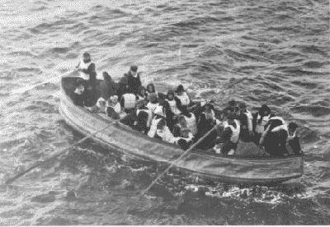

In one of the last overcrowded lifeboats to leave the Titanic stood Mrs. Emily Richards, then 24, and about to join her husband in the USA. She had her I0-month-old baby, George, in her arms, She said later: 'We pulled away from the liner. The sea was full of wreckage and bodies. Some people had jumped overboard and were screaming for help. The sea was very icy. We wanted to pick them up but our boat was overloaded already.”

As the lifeboats drifted away from the doomed liner, the passengers who had escaped looked back helplessly on a scene that they thought could only have been dreamed up in hell. The Titanic lay with rows and rows of lights still blazing on a millpond sea dotted with icebergs. The ship was still not far from the monstrous grey mass of the giant iceberg that it had struck. The liner's four funnels, towering 175 feet above its keel, stood out against the starry sky. They leaned forward at a crazy angle. And at 2,20 a.m. the Titanic began to slip beneath the surface. The band was still playing, its music carrying eerily across the still expanse of sea. But now the ragtime had ended, and a hymn was struck up. Some survivors remember it as the old hymn Autumn; others say it was ~"Nearer My God To Thee. The ship's lights illuminated hundreds of spider-like figures clinging to the decks and to the sides of the liner as its propellers were lifted above the water line. One by one, they fell or jumped into the sea to certain, freezing death.

'There was a long, rumbling boom, like distant thunder,' said Emily Richards. 'The lights went out, flashed on again, then went out for good. The stern rose until it was pointing almost straight up in the air. Then the TitanIc slipped swiftly and smoothly out of sight.'

The lifeboats packed with shivering survivors drifted until dawn, when the liner Carpathia arrived on the scene and picked up 705 of them. - Most of the survivors were first- and second-class ticket holders, These had been given priority in the lifeboats, and all their children were saved. Of the steerage children only a third survived.

Task
The way in which the passengers coped with the disaster has led some to say:

“It would not be like that if it happened today”.

1. Work with a partner. Make a list of events during the sinking and the filling of the lifeboats that you think would not happen today. Explain why.

2. Share your ideas with the rest of the class.

Newspaper Reports

In this part of the unit you are going to write a newspaper report of the sinking of The Titanic. First, however, you need to think about how a news report is written.

Task: The following two reports are taken from recent newspapers. Read them carefully and answer the questions that follow:

JEWELER: CELL PHONE SAVED LIFE
A JEWELERY shop manager shot in a robbery was saved because the bullet hit his mobile, a court heard yesterday.
Darren Prior, 25, ran after a hooded gunman who held up the shop and fled with $5,000 of rings.
The robber fired at him before being driven off.
Mr Prior said: "It felt like a punch. I pulled open my jacket and realised it had hit my phone."
Sean Henry, 35, of Wallington, Surrey, denies attempted murder and robbery at Amore Jewellers, Horsham, West Sussex, in September 2005.
Timothy Cole, 30, of Bognor Regis, West Sussex, the alleged getaway driver, denies robbery. The trial continues.

Answer these questions:

- What do you learn from the headline?

- Why is the first paragraph so important?

- Why do you think the reporter includes a quote from the man who was shot?

- What do you notice about the tenses of the verbs?

- Why do you think the reporter does not include more details?

Task – Now read the second report and answer the questions with a partner.

iPods can make pacemakers Malfunction

iPods can cause cardiac implantable pacemakers to malfunction by interfering with the electromagnetic equipment monitoring the heart, according to a study presented by a 17-year-old high school student to a meeting of heart specialists on Thursday.
The study tested the effect of the portable music devices on 100 patients, whose mean age was 77, outfitted with pacemakers. Electrical interference was detected half of the time when the iPod was held just 2 inches from the patient's chest for 5 to 10 seconds.

The study did not examine any portable music devices other than iPods, which are made by Apple Inc.
In some cases, the iPods caused interference when held 18 inches from the chest. Interfering with the equipment caused the device to misread the heart's pacing and in one case caused the pacemaker to stop functioning altogether.
The study was held at the Thoracic and Cardiovascular Institute at Michigan State University. The results were presented at the Heart Rhythm Society annual meeting in Denver.
Jay Thaker, lead author of the study and a student at Okemos High School in Okemos, Michigan, concluded that iPod interference can lead physicians to misdiagnose actual heart function.

Group Work

Good reports tell the reader Who, Where, What, When, How and Why something happened.

Using those key words as headings, collect information from the article to answer the questions Who, Where, What, When, How and Why

WHO:

WHERE:

WHAT:

WHEN:

HOW:

WHY:

What do you notice about the tenses of the verbs?

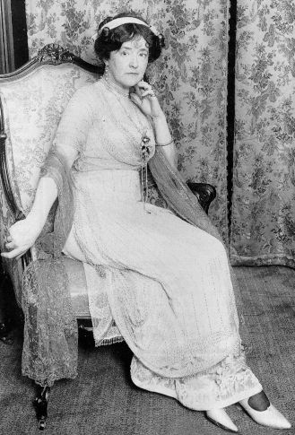
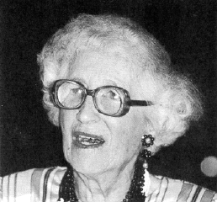
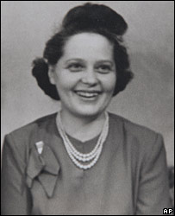
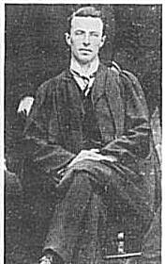
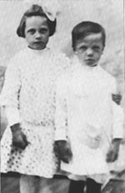
“I survived the Titanic!”

Survivor’s True Story
It must have been a little after ten o'clock when my husband came in and woke me up. He sat and talked to me for how long l do not know, before he began to make ready to go to bed. And then the crash! The sensation to me was as if the ship had been seized by a giant hand and shaken once, twice then stopped dead in its course: That is to say there was a long backward jerk, followed by a shorter one. I was not thrown out of my berth and my husband staggered on his feet only slightly. We heard no strange sounds, no rending of plates and woodwork; but we noticed that the engines had stopped running.
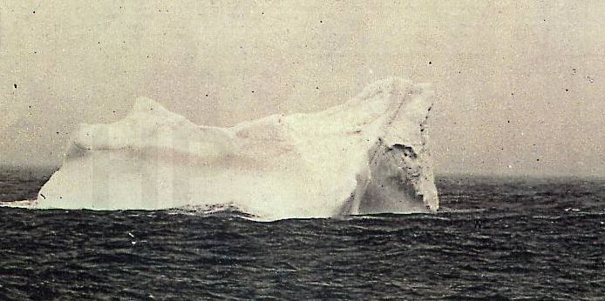

I think my husband would have retired to his berth Without asking any more questions about the accident but suddenly we heard hundreds of people running along the passageway in front of our door, 'We had better go on deck and see what's wrong," he said.

When we reached the second cabin promenade deck we found a great many people there: Some officers were walking up and down; but I want to say that at that time no-one was frightened.

Our party of three stood close together. Suddenly there was a commotion near one of the gangways and we saw a stoker come climbing up from below. He stopped a few feet away from us. All of the fingers of one hand had been cut off. Blood was running from the stumps and blood was spattered over his face and over his clothes; l asked him if there was any danger. “Danger,” he screamed at the top of his voice, I should just say so! It's hell down below, look at me. This boat will sink like a stone in ten minutes.' He staggered away and lay down fainting with his head on a coil of rope: At this moment I got my first grip of fear -awful sickening fear. That poor man with his bleeding hand and his speckled face brought up a picture of smashed engines and mangled human bodies. I hung on to my husband's arm and although he was very brave, and not trembling. I saw that his face was as white as paper. We realised that the accident was much worse than we had supposed, but even then I and all the others about me of whom I have any knowledge did not believe that the Titanic would go down. I have no clear idea of what happened during the next quarter of an hour. I saw First Officer Murdock place guards by the gangways to prevent others like the wounded stoker from coming on deck. He was a masterful man, astoundingly brave and cool. I had met him the day before when he was inspecting the second cabin quarters, and thought him a bulldog of a man who would not he afraid of anything. This proved to be true, he kept order to the last, and died at his post. They say he shot himself. I do not know.

Those in charge must have herded us toward the nearest boat deck for that is where I presently found myself, still clinging to my husband's arm, and with little Marjorie beside me. Many women were standing with their husbands and there was no confusion.

Then above the clamour of the people asking questions of each other, there came the terrible cry “Lower the boats! Women and children first. They struck utter terror into my heart and now they will ring in my ears until the day I die. They meant my own safety but they also meant the greatest loss I have ever suffered" - the life of my husband.

The third boat was about half full when a sailor caught Marjorie in his arms, and tore her away from me and threw her into the boat. The deck seemed to be slipping under my feet. It was leaning at a sharp angle for the ship was then sinking fast, bows down. I clung desperately to my husband.

A man seized me by the arm then another threw both his arms about my waist and dragged me away by main strength. I heard my husband say,

'Go, Lotty, for God's sake be brave and go! I'll get a seat in another boat'

The men who held me rushed me across the deck and hurled me bodily into the lifeboat. I landed on one shoulder arid bruised it badly. Other women were crowding behind me, but I stumbled to my feet and saw over their heads my husband's back as he walked steadily down the deck and disappeared among the men. His face was turned away so that I never saw it again, but I know that he went unafraid to his death.

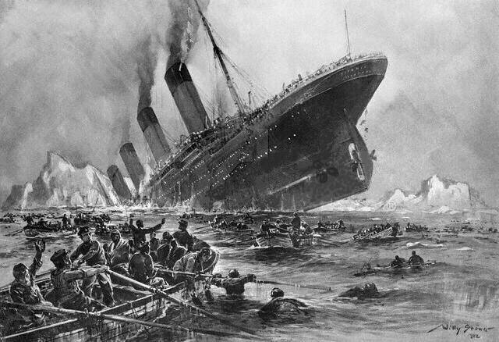

A Survivor’s Story: Reading for Meaning

Task:
Answer the following questions

- List 5 facts about the sinking that the survivor describes

- Everyone was trying to be very calm, orderly and brave.

Find three examples that show the passengers were very nervous and frightened.

- What is the effect on the reader of the writer’s use of these words:

  - “The sensation to me was as if the ship had been seized by a giant hand and shaken once, twice and then stopped dead…..” (Paragraph 1)

  - I had met him the day before …………………… and thought him a bulldog of a man who would not be afraid of anything. (Paragraph 4)

  - “Go, Lotty, for God’s sake be brave and go! I’ll get a seat in another boat” (Paragraph 10)

- How does the writer feel about:

  - First Officer Murdock?

  - Her husband?

  - The way that she and her daughter were herded into a lifeboat?

NB In your answers, explain how you know the way the writer feels.

- The writer sometimes uses the actual words that people used on the boat.

Copy four examples from the story and explain the impact the writer hopes they will have on the reader.

A Survivor’s Story

You are going to write a survivor’s story of your own. First, you are going to create the character, you are going to write about.

Creating Your Character

Answer the following questions and build up a character:

- What is your name?
- Why were you on the ship? E.g. Holiday maker? Immigrating to America? One of the crew?
- Were you alone or did you have friends and family on board?
- What happened to them?
- Where were you when the boat was struck by the iceberg?
- What were your first thoughts?
- When did you realise how serious it was?
- What was the atmosphere like on the ship?
- What did you do?
- How did you escape?
- What happened when you were in the water or in a lifeboat?
- How were you rescued?
- How did you feel when you were safe? What were you thinking about?
- How do you feel now?

Planning your work

Good pieces of personal writing are a mixture of facts and the writer’s thoughts and feelings about what happened.

Task: On Googledocs, make a table like the one below and fill it in

Events | Thoughts and Feelings
I was playing cards in of the lounges when the ship shuddered slightly and the lights flickered off and on. Then, everything seemed to return to normal.  Someone came in and said that we had hit something. I said I had hit a winning streak. | Thought little of it. I was winning and having a good time.  No-one seemed worried. I didn’t even give it a second thought.

Task

- Show your ideas to a partner and then make any changes you may have discussed

- Share your ideas with the rest of the class

Writing Task:
Write your own survivor’s story in Googledocs.

You should:
a) Use your plan to help you
b) Write in the First Person
c) Include thoughts, feelings and impressions
d) Use descriptive words and sentences

Drama Task

Now you are going to use your “Survivor’s Story” to help you to create a short drama script.

In small groups, you are going to write the scene where some of the survivors have just been rescued. They are taken off the lifeboats and put into a cabin on a rescue ship. They are shocked, frightened, perhaps relieved and tired. They are left to relax and to rest but, very quickly, they begin a conversation about their lives and what has happened.

You are going to prepare the script of this scene, rehearse it and then act it out for the class.

Things to remember:

You may all come from different parts of the boat: you might be a rich or poor passenger or a member of the crew
You may have been on board the Titanic for very different reasons. For example, on vacation, or as an emigrant going to start a new life in America or as a worker.
Some of you may have lost family or friends on the ship or you may have been separated from them and not know if they are alive or dead

You will also need to think about:

where you will all be on the stage;
what you will be wearing;
what props you may need
whether you will have a script to work from or if you will improvise

Step 1 Talk about how your performance will be organised and keep a record to share with your teacher.

Step 2 Write or improvise your script

Step 3 Rehearse your script until you know it well

Step 4 Sort out the props you will need

Step 5 Perform your play for the class
Titan or Titanic
Fate
or
Just one of those things?

Futility

The following story was written by one of the passengers on the Titanic several years before the sinking. Read the story carefully so that you can compare it with what you have already read.

She was the largest craft afloat and the greatest of the works of men. In her construction and maintenance were involved every science, profession, and trade known to civilisation. On her bridge were officers, who, besides being the pick of the Royal Navy, had passed rigid examinations in all studies that pertained to the winds, tides, currents, and geography of the sea; they were not only seamen, but scientists. The same professional standard applied to the personnel of the engine- room, and the first steward's department was equal to that of a first-class hotel.

Two brass bands, two orchestras, and a theatrical company entertained the passengers during waking hours; a corps of physicians administered to the temporal, and a corps of chaplains to the spiritual welfare of all on board, while a well-drilled fire-company soothed the fears of nervous ones and added to the general entertainment by daily practice with their apparatus.

From her lofty bridge ran hidden telegraph lines to the bow, stern engine-room, crow's-nest on the foremast, and to all parts of the ship where work was done, each wire terminating in a marked dial with a movable indicator, containing in its scope every order and answer required in handling the massive hulk, either at the dock or at sea—which eliminated, to a great extent, the hoarse, nerve-racking shouts of officers and sailors.

From the bridge, engine-room, and a dozen places on her deck the ninety-two doors of nineteen water-tight compartments could be closed in half a minute by turning a lever. These doors would also close automatically in the presence of water. With nine compartments flooded the ship would still float, and as no known accident of the sea could possibly fill this many, the steamship Titan was considered practically unsinkable.

Built of steel throughout, and for passenger traffic only, she carried no combustible cargo to threaten her destruction by fire; and the immunity from the demand for cargo space had enabled her designers to discard the flat, kettle-bottom of cargo boats and give her the sharp dead-rise -or slant from the keel -of a steam yacht, and this improved her behaviour in a seaway. She was eight hundred feet long, of seventy thousand tons' displacement, seventy-five thousand horse-power, and on her trial trip had steamed at a rate of twenty-five knots an hour over the bottom, in the face of unconsidered winds, tides, and currents. In short, she was a floating city- containing within her steel walls all that tends to minimise the dangers and discomforts of the Atlantic voyage -all that makes life enjoyable.

Unsinkable -indestructible, she carried as few boats as would satisfy the laws. These, twenty-four in number, were securely covered and lashed down to their chocks on the upper deck, and if launched would hold five hundred people. She carried no useless, cumbersome life-rafts; but -because the law required it -each of the three thousand berths in the passengers', officers', and crew's quarters contained a cork jacket, while about twenty circular life-buoys were strewn along the rails.

Task 1
a) Find five similarities between the SS Titan and The Titanic
b) List any differences you can find

CHAPTER VII

Seventy-five thousand tons -dead-weight -rushing through the fog at the rate of fifty feet a second, had hurled itself at an iceberg. Had the impact been received by a perpendicular wall, the elastic resistance of bending plates and frames would have overcome the momentum with no more damage to the passengers than a severe shaking up, and to the ship than the crushing in of her bows and the killing, to a man, of the watch below. She would have backed off, and, slightly down by the head, finished the voyage at reduced speed, to rebuild on insurance money, and benefit, largely, in the end, by the consequent advertising of her indestructibility. But a low beach, possibly formed by the recent over-turning of the berg, received the Titan, and with her keel cutting the ice like the steel runner of an ice-boat, and her great weight resting on the starboard bilge, she rose out of the sea, higher and higher -until the propellers in the stern were half exposed -then, meeting an easy, spiral rise in the ice under her port bow, she heeled, overbalanced, and crashed down on her side, to starboard.

The holding-down bolts of twelve boilers and three triple-expansion engines, unintended to hold such weights from a perpendicular flooring, snapped, and down through a maze of ladders, gratings, and fore-and-aft bulkheads came these giant masses of steel and iron, puncturing the-sides of the ship, even where backed by solid, resisting ice; and filling the engine- and boiler-rooms with scalding steam, which brought a quick, though tortured death, to each of the hundred men on duty in the engineer's department.

Amid the roar of escaping steam, and the bee-like buzzing of nearly three thousand human voices, raised in agonized screams and callings from within the inclosing walls, and the whistling of air through hundreds of open dead-lights as the water, entering the holes of the crushed and riven starboard side, expelled it, the Titan moved slowly backward and launched herself into the sea, where she floated low on her side -a dying monster, groaning with her death-wound.

A solid, pyramid-like hummock of ice, left to starboard as the steamer ascended, and which projected close alongside the upper, or boat-deck, as she fell over, had caught, in succession, every pair of davits to starboard. bending and wrenching them, smashing boats, and snapping tackles and gripes, until, as the ship cleared herself, it capped the pile of wreckage strewing the ice in front of, and round it, with the end and broken stanchions of the bridge. And in this shattered, box-like structure, dazed by the sweeping fall through an arc of seventy-foot radius, crouched Rowland, bleeding from a cut in his head. and still holding to his breast the little girl -now too frightened to cry.

By an effort of will, he aroused himself and looked. To his eyesight, twisted and fixed to a shorter focus by the drug he had taken. the steamship was little more than a blotch on the moon-whitened fog; yet he thought he could see men clambering and working on the upper davits. and the nearest boat -No. 24 - seemed to be swinging by the tackles. Then the fog shut her out, though her position was still indicated by the roaring of steam from her iron lungs. This ceased in time, leaving behind it the horrid humming sound and whistling of air; and when this too was suddenly hushed, and the ensuing silence broken by dull, booming reports -as from bursting compartments -Rowland knew that the holocaust was complete; that the invincible Titan, with nearly all of her people, unable to climb vertical floors and ceilings, was beneath the surface of the sea.

Task 2
Create a Venn Diagram with your group to identify the following:

a) How is the second part of the story similar to the sinking of the Titanic?
b) How is it different?
c) In your opinion, how did the passenger of the Titanic come to write this story?

Task 3
You are now going to compare, in writing, the similarities and differences between what happened to The Titan and The Titanic. Use your Venn Diagram to assist you and complete your assignment in Googledocs.

Planning your writing

You could use the following headings and suggestions to help you to gather your ideas:

Introduction

- You could explain how the passenger on the Titanic wrote a very similar story and then died when it sank
- You might ask the reader to consider if it was fate or just one of those things

Similarities

- You should collect all the similarities and write about them in the order you think will be best
- You must use words that show you are comparing: e.g. similarly, in the same way, also etc.

Differences

- You should collect all the differences and write about them in the order you think will be best
- You must use words that show you are showing the differences: e.g. on the other hand, however, but etc.

Final Paragraph

You could give your opinion on the idea that it might be fate or just a coincidence.

Writing Tips

Your teacher will be looking for:

- Clear explanation
- Good use of paragraphs
- Varied sentences and vocabulary
- Evidence to support your main ideas


Design
a
Titanic
Brochure

The Titanic Brochure

In this part of the unit you are going to design and make a brochure or leaflet advertising the first voyage of the Titanic. You will need to think about three things before you start:

1) What you want to say about the Titanic
2) How your brochure will look—its design
3) The kind of language you want to use

What should I say?

You are advertising the first voyage on a superb new ship. You will want to write about all of the boats best features. You will also have to decide who you are aiming your brochure at.

Will it be the rich first class passengers?
Will it be the poorer men and women who
want to travel to America to start a new life?

What you say about the boat will depend on who you choose.

Task
a) On your organizer, write a sentence explaining who
your brochure will be aimed at.

b) Now write the heading: “Contents of my brochure” and
make a list of all the things you want to include about
the ship and the journey.

c) Add any good ideas to your list

Brochure/Leaflet Design

Look at the brochures on this and the next page

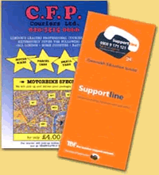
Task

1. Make a list of five things you might expect to find
in the way a brochure or leaflet is set out

e.g. Different font styles
Bullet points

2. Share your ideas with a partner

3. Share your ideas with class and create a class list.


Designers use the things you have been discussing to improve the presentation and to have an impact on the reader.

The Language of Brochures and Leaflets

The aim of your leaflet is to persuade people to pay for a ticket on the first voyage. Your writing will need to be persuasive. You are going to look at some examples of this kind of writing and try to work out how to sound persuasive.

Look at the following advert for The Park Royal Hotel

The Park Royal ****

The Park Royal, Stretton Road, Stretton, Warrington, WA4 4NS

Tel: 01925 730706Fax: 01925 730740Email: parkroyal@qhotels.co.uk.

The Park Royal is a gem set in the heart of Cheshire. There’s the Cheshire countryside, sleepy villages, meandering rivers and mirror-smooth canals – plus the spin of the city too! With brilliant boutique shopping, Chester awaits your every fashion whim.
Enter your en-suite bedroom and you’ll feel more relaxed in seconds, surrounded by uncompromising elegance. Our 146 spacious bedrooms have all the indulgences you expect, mini-bar, satellite TV, tea, coffee and telephone – choose the Tower Suite and you even have your own spiral staircase. And if you want to arrive by helicopter, unlike most hotels in Cheshire we have our own helipad in the grounds!
And for tomorrow? Aintree perhaps, Chester Cathedral, Chester Zoo, the Gateway Theatre, Beeston Castle – or a spot of ghost hunting? But then, can you resist that promise of world-class shopping?
Task 1
Answer these questions
1. What sort of things does each paragraph tell you about?

2. What impression do they give of the hotel?

3. Give three examples of how the advert makes the hotel sound luxurious?

4. Choose four words or phrases that the writer uses deliberately to make the reader feel enthusiastic about Park Royal Hotel.
What do they make the reader think about the place?
Task 2
Share your answers with the rest of the class
What have you learnt about the kind of language used in brochures/leaflets?

Task 3
Look at the advert printed below for Tankersley Manor.

Tankersley Manor ****
Church Lane, Tankersley, Barnsley, South Yorkshire, S75 3DQ
Tel: 01226 744700 - Fax: 01226 745405 - email: tankersleymanor@qhotels.co.uk
Backing onto woodland, Tankersley Manor sensitively incorporates a 17th century building within a modern hotel with many original features retained. Built of mellow stone many rooms have exposed beams and deep windowsills of York stone.
When the time comes to enjoy a meal at Tankersley Manor you can choose from our charming restaurant, serving the finest cuisine, or the less formal Onward Arms, our in-house pub at the centre of the hotel that has a busy traditional atmosphere complete with roaring fires and brass and copper decorations. Here you can enjoy delicious meals over a few drinks. For those who prefer a little peace and quiet, retreat to the lounge or cocktail bar.
There are 100 rooms to choose from, including suites and rooms, or perhaps you’d like a four-poster suite to spice up the romance in your life! The newly-opened Reflections Spa and Leisure Club invites guests to enjoy its indoor pool, gym, steam and sauna rooms and indulge in body treatments, perfect for relaxing after a trek in the Yorkshire countryside.
Well situated for exploring the area with its many indoor and outdoor attractions, Tankersley Manor can offer a memorable and luxurious break.

Facilities
- 4 Star
- 100 Bedrooms
- Reflections Spa and Leisure facilities; see our Spa offers
- Manor Restaurant
- Onward Arms Pub
- Easy access to Sheffield
- High Speed Internet Access Facilities (Broadband)
- Check in from 3.00pm, check out by 11.00am

- What sort of things does each paragraph tell you about?
- What impression do they give of the hotel?
- Give three examples of how the advert makes the hotel sound luxurious?
- Choose four words or phrases that the writer uses deliberately to make the reader feel enthusiastic about Park Royal Hotel.
What do they make the reader think about the place?
- In your opinion, which is the better advertisement? Why?
Your Turn
Draft your brochure using the information your have collected
Tips
Your teacher will be looking for:
Interesting and persuasive content
An eye-catching and helpful presentation or layout
Persuasive language
Good spelling and punctuation
Neat, careful work

