The Treaty of Versailles was the peace settlement signed after World War One had ended in 1918 and in the shadow of the Russian Revolution and other events in Russia. The treaty was signed at the vast Versailles Palace near Paris - hence its title - between Germany and the Allies. The three most important politicians there were David Lloyd George, Georges Clemenceau and Woodrow Wilson. The Versailles Palace was considered the most appropriate venue simply because of its size - many hundreds of people were involved in the process and the final signing ceremony in the Hall of Mirrors could accommodate hundreds of dignitaries. Many wanted Germany, now led by Friedrich Ebert, smashed - others, like Lloyd George, were privately more cautious.
Background
World War One had left Europe devastated. Those countries that had fought in it, had suffered casualties never experienced before:
Britain : 750,000 soldiers killed; 1,500,000 wounded
France : 1,400,000 soldiers killed; 2,500,000 wounded
Belgium : 50,000 soldiers killed
Italy : 600,000 soldiers killed
Russia : 1,700,000 soldiers killed
America : 116,000 soldiers killed
Those who had fought against the Allies suffered heavy casualties as well:
Germany : 2,000,000 soldiers killed
Austria-Hungary : 1,200,000 soldiers killed
Turkey : 325,000 soldiers killed
Bulgaria : 100,000 soldiers killed
The total deaths of all nations who fought in the war is thought to have been 8.5 million with 21 million being wounded.
Alongside these statistics, was the fact that vast areas of north-eastern Europe had been reduced to rubble. Flanders in Belgium had been all but destroyed with the ancient city of Ypres being devastated. The homes of 750,000 French people were destroyed and the infrastructure of this region had also been severely damaged. Roads, coal mines, telegraph poles had all been destroyed and such a loss greatly hindered the area's ability to function normally.
The victors from World War One were in no mood to be charitable to the defeated nations and Germany in particular was held responsible for the war and its consequences.

The attitude towards Germany of the "Big Three"
The treaty was signed on June 28th 1919 after months of argument and negotiation amongst the so-called "Big Three" as to what the treaty should contain.
The "Big Three" were David Lloyd George of Britain, Clemenceau of France and Woodrow Wilson of America.
David Lloyd George of Great Britain had two views on how Germany should be treated.
His public image was simple. He was a politician and politicians needed the support of the public to succeed in elections. If he had come across as being soft on Germany, he would have been speedily voted out of office. The British public was after revenge and Lloyd George's public image reflected this mood. "Hang the Kaiser" and "Make Germany Pay" were two very common calls in the era immediately after the end of the war and Lloyd George, looking for public support, echoed these views.
Georges Clemenceau of France had one very simple belief - Germany should be brought to its knees so that she could never start a war again.
This reflected the views of the French public but it was also what Clemenceau himself believed in. He had seen the north-east corner of France destroyed and he determined that Germany should never be allowed to do this again. "The Tiger" did not have to adapt his policies to suit the French public - the French leader and the French public both thought alike.
Woodrow Wilson of America had been genuinely stunned by the savagery of the Great War. He could not understand how an advanced civilization could have reduced itself so that it had created so much devastation.
In America, there was a growing desire for the government to adopt a policy of isolation and leave Europe to its own devices. In failing health, Wilson wanted America to concentrate on itself and, despite developing the idea of a League of Nations, he wanted an American input into Europe to be kept to a minimum. He believed that Germany should be punished but in a way that would lead to European reconciliation as opposed to revenge.
He had already written about what he believed the world should be like in his "Fourteen Points" The main points in this document were:
1) no more secret treaties
2) countries must seek to reduce their weapons and their armed forces
3) national self-determination should allow people of the same nationality to govern themselves and one nationality should not have the power to govern another
4) all countries should belong to the League of Nations.
Therefore, the three main nations in the lead up to the treaty were far from united on how Germany should be treated. The eventual treaty seemed to satisfy everyone on the sides of the Allies. For France, it appeared as if Germany had been smashed; for Britain, Lloyd George was satisfied that enough of Germany's power had been left to act as a buffer to communist expansion from Russia ; Wilson was simply happy that the proceedings had finished so that he could return home.
So what exactly did the treaty do to Germany?
The terms of the Treaty of Versailles
The treaty can be divided into a number of sections; territorial, military, financial and general.
Territorial
The following land was taken away from Germany :
Alsace-Lorraine (given to France)
Eupen and Malmedy (given to Belgium)
Northern Schleswig (given to Denmark)
Hultschin (given to Czechoslovakia)
West Prussia, Posen and Upper Silesia (given to Poland)
The Saar, Danzig and Memel were put under the control of the League of Nations and the people of these regions would be allowed to vote to stay in Germany or not in a future referendum.
The League of Nations also took control of Germany's overseas colonies.
Germany had to return to Russia land taken in the Treaty of Brest-Litovsk. Some of this land was made into new states : Estonia, Lithuania and Latvia. An enlarged Poland also received some of this land.
Military
Germany’s army was reduced to 100,000 men; the army was not allowed tanks
She was not allowed an airforce She was allowed only 6 capital naval ships and no submarines The west of the Rhineland and 50 kms east of the River Rhine was made into a demilitarised zone (DMZ). No German soldier or weapon was allowed into this zone. The Allies were to keep an army of occupation on the west bank of the Rhine for 15 years.
Financial
The loss of vital industrial territory would be a severe blow to any attempts by Germany to rebuild her economy. Coal from the Saar and Upper Silesia in particular was a vital economic loss. Combined with the financial penalties linked to reparations, it seemed clear to Germany that the Allies wanted nothing else but to bankrupt her.
Germany was also forbidden to unite with Austria to form one superstate, in an attempt to keep her economic potential to a minimum.
General
There are three vital clauses here:
1. Germany had to admit full responsibility for starting the war. This was Clause 231 - the infamous "War Guilt Clause". 2. Germany, as she was responsible for starting the war as stated in clause 231, was, therefore responsible for all the war damage caused by the First World War. Therefore, she had to pay reparations, the bulk of which would go to France and Belgium to pay for the damage done to the infrastructure of both countries by the war. Quite literally, reparations would be used to pay for the damage to be repaired. Payment could be in kind or cash. The figure was not set at Versailles - it was to be determined later. The Germans were told to write a blank cheque which the Allies would cash when it suited them. The figure was eventually put at £6,600 million - a huge sum of money well beyond Germany’s ability to pay.
3. A League of Nations was set up to keep world peace.
In fact, the first 26 clauses of the treaty dealt with the League's organisation.
The German reaction to the Treaty of Versailles
After agreeing to the Armistice in November 1918, the Germans had been convinced that they would be consulted by the Allies on the contents of the Treaty. This did not happen and the Germans were in no position to continue the war as her army had all but disintegrated. Though this lack of consultation angered them, there was nothing they could do about it. Therefore, the first time that the German representatives saw the terms of the Treaty was just weeks before they were due to sign it in the Hall of Mirrors at the Palace of Versailles on June 28th 1919.
There was anger throughout Germany when the terms were made public. The Treaty became known as a Diktat - as it was being forced on them and the Germans had no choice but to sign it. Many in Germany did not want the Treaty signed, but the representatives there knew that they had no choice as German was incapable of restarting the war again.
In one last gesture of defiance, the captured German naval force held at Scapa Flow (north of Scotland) scuttled itself i.e. deliberately sank itself.
Germany was given two choices:
1) sign the Treaty or
2) be invaded by the Allies.
They signed the Treaty as in reality they had no choice. When the ceremony was over, Clemenceau went out into the gardens of Versailles and said "It is a beautiful day".
The other peace settlements
It is often forgotten, that with the energy put into the punishment of Germany, other countries fought on her side and, equally, had to be dealt with. These countries were Austria-Hungary, Bulgaria and the Ottoman Empire.
Austria-Hungary had to sign two peace settlements, indicative of the fact that this state was shortly to be divided into two.
Austria signed the Treaty of Saint Germain.
Hungary signed the Treaty of Trianon.
Austria and Hungary were treated as two completely new countries after these treaties were signed. Both lost land to neighbouring countries; the new state of Czechoslovakia was effectively created out of this carve up of land; large blocks of land went to Poland, Romania and Yugoslavia. Part of Austria went to Italy.
Both new countries had to reduce their military capability and both states had to pay reparations for war damage. However, the figures involved were nowhere near as high as the figure imposed on Germany.
Bulgaria had to sign the Treaty of Neuilly. Bulgaria lost land to the new state of Yugoslavia, had to reduce her military capability and had to pay reparations.
The Ottoman Empire had to sign the Treaty of Sevres.
The Ottoman Empire lost:
most of her land in Europe. Turkey was left with but a toe hold on what is considered Europe. the Turkish Straits was put under the control of the League of Nations at a time when it was dominated by Britain and France. the land held by Turkey in Arabia was made into a mandate - the land was ruled by the British and French until the people of the areas were ready to govern themselves. Syria and Lebanon went to France while Iraq, Transjordan and Palestine went to Britain.
Armies from Britain, France, Greece and Italy occupied what was left of Turkey - the area known as Asia Minor.
The treaty only served to anger the nationalist Turks who sought to overturn it. This they started to do in 1921.

Europe in 1914

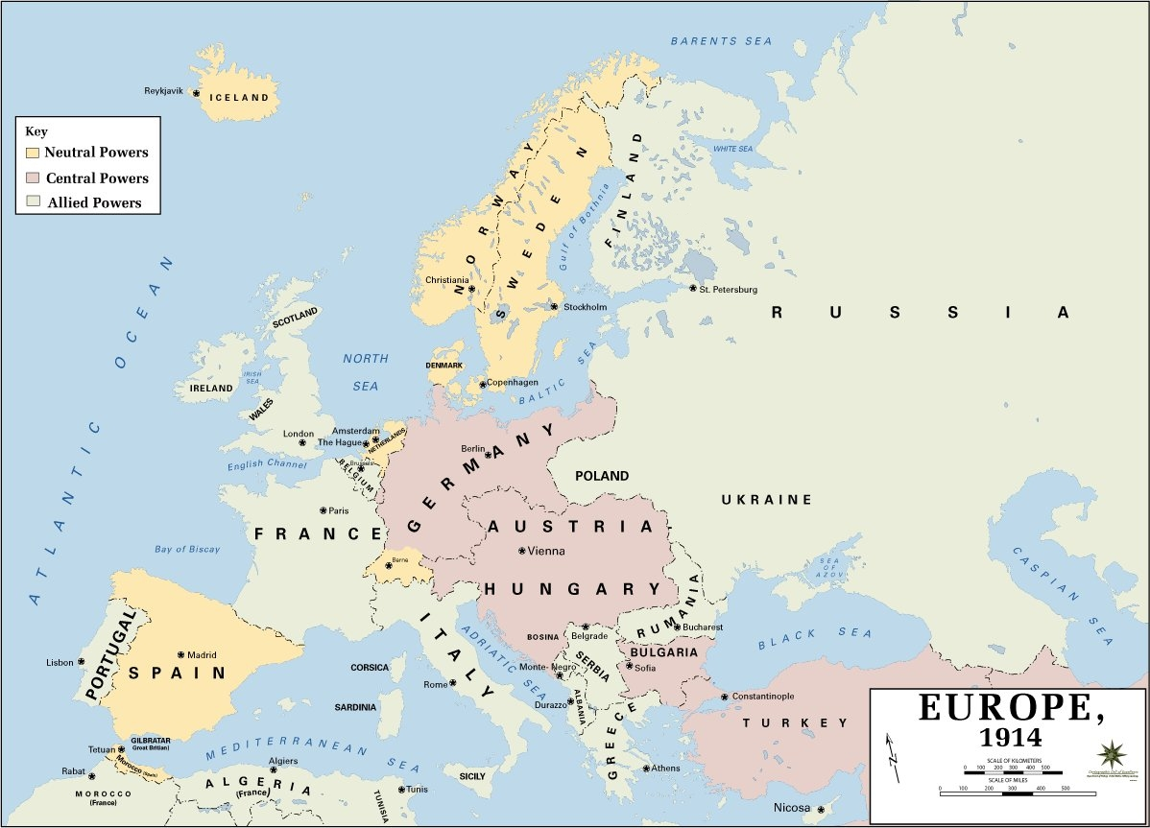

Map of Europe in 1919

