**Structure of an Atom**

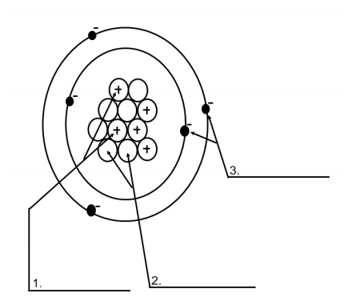Label the parts of an atom on the diagram below.

4. What type of charge does a proton have? _____________

5. What type of charge does a neutron have? ____________

6. What type of charge does an   
electron have? ____________

7. Which two subatomic particles are located in the nucleus of an atom? ______________________________

8. If an atom has 35 protons in the nucleus, how many electrons will it have orbiting the nucleus? ________

9. What is the atomic number of the atom in the diagram above? ______________________________

10. What is the atomic mass/mass number of the atom in the diagram above? _________________________

11. How many protons are in the nucleus of an atom with an atomic number of 15? ______________________

12. How many electrons are in the nucleus of an atom with an atomic number of 20? Label the parts of an atom on the diagram below.

13. Fill out the chart below using your notes and above information

|  |  |  |
| --- | --- | --- |
| ***Subatomic Particle*** | ***Electric Charge*** | ***Location in Atom*** |
| **Proton** |  |  |
|  | **None** |  |
|  |  | **Orbits nucleus** |

14. Open your agenda book to the periodic table (in the back index). Tell me which elements correspond to the atomic numbers below.

|  |  |
| --- | --- |
| ***Atomic Number*** | ***Element Name*** |
| **22** |  |
| **30** |  |
| **8** |  |