Chapter 4: Forensic Fingerprints

1. Using information from the online informational article (page 21), label **ONE Bifurcations, Ridge Endings, Short Ridges, Islands, Enclosure, and Ridge Crossing** on each of the finger prints. **Ridge Crossings** are rare, but do your best.

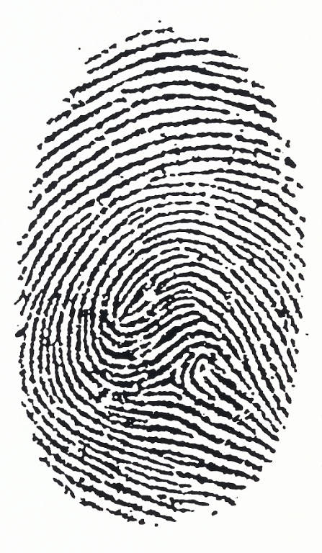 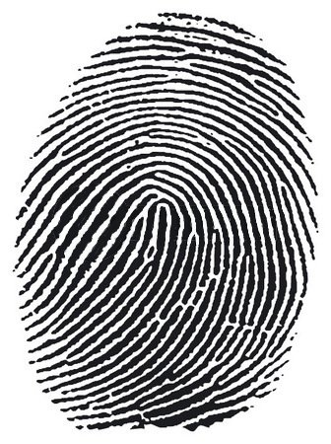

1. According the reading how many ways to develop prints are there currently and how do you decide which technique or method to use?
2. What are the three principles of fingerprinting?
   1. _______________________________________________________________________________________________________________________________________________________________________________________________________________________________________________________________
   2. _______________________________________________________________________________________________________________________________________________________________________________________________________________________________________________________________
   3. _______________________________________________________________________________________________________________________________________________________________________________________________________________________________________________________________

***First Principle***

1. How many possible fingerprints can be theoretically calculated due to the various ridge characteristics found among the human population?
2. What are the individuality of finger prints determined by?
3. Define minutiea.
4. What are the two ways jurors can be made aware of matched fingerprint in the judicial system?

***Second Principle***

1. Evolutionarily, why do humans (and primates in general) have fingerprints?
2. How does our body physiologically (biochemically) create a fingerprint that we leave behind on an object?
3. What are fingerprints called that we leave on every object that we touch and seem to be invisible to the naked eye most of the time?
4. How can criminal remove their fingerprints?
5. Why is trying to remove your fingerprints not the best idea? Give two reasons.

***Third Principle***

**Word Bank** – Can be used more than once

Loop Accidental whorl

Whorl Core

Arch Radial loop

Double loop whorl Ulnar loop

Delta Tented Arch

1. ___________________________________ Contain no deltas or cores
2. ___________________________________ A loop opening toward the thumb
3. ___________________________________ Contains one or more cores and a minimum of two deltas
4. ___________________________________ Approximately 30-35% of humans have
5. ___________________________________ A triangular shaped ridge characteristic with type lines surround it
6. ___________________________________ Approximately 60-65% of human have
7. ___________________________________ Has one or more ridges that enter from one side of the print, re- curve, and exit the same side
8. ___________________________________ Approximately 5% of humans have
9. ___________________________________ Made up of two loops combined into one fingerprint the wrap around one another
10. ___________________________________ The approximate center of the fingerprint
11. ___________________________________ A loop opening toward the pinky finger
12. ___________________________________ May consist of a combination loop and plain whorl or loop and tented arch