Anthropology Quiz #2 Review (slides 23- 49)

1. What cranial suture would be reliable to tell if someone is over or under the 20-25 year age mark? Explain where it is located on the skull.
2. Greatest activity of epiphyseal closures occurs between which ages? What did the epiphysis look like prior to closing? Maybe draw a picture.
3. Dentition is most widely used to identify which age groupings? Be specific with age groups
4. What is another name for the epiphyseal regions of the bones, and why is it important that they stay intact throughout the growth process?
5. What is the last epiphyseal plate to close? At what age?
6. Why do anthropologist believe dental eruptions are tied closely to genetics?
7. Adult teeth are judge by tooth wear or degeneration. Give at least four ways odontologists can estimate the age of adult remains by looking at the teeth only.
8. How many teeth are there in the child’s dental chart vs how many are in an adult’s?
9. Give three examples of how you can identify the gender of a skeleton.
10. Give three examples of how you can identify the race of a skeleton.

Matching

1. 18 years
2. Between age 1 and 2
3. Between 12-16 weeks post-fertilization
4. Between 10-12 years
5. Between 6-8 years
6. Third molars emerge
7. Most “baby” teeth emerge
8. Two permanent incisors and the first permanent molars appears
9. Tooth formation begins
10. Most permanent canines, premolars, and second permanent molars emerge

Label

1. Label #9 with its name.
2. Place a cavity marking on #15.
3. 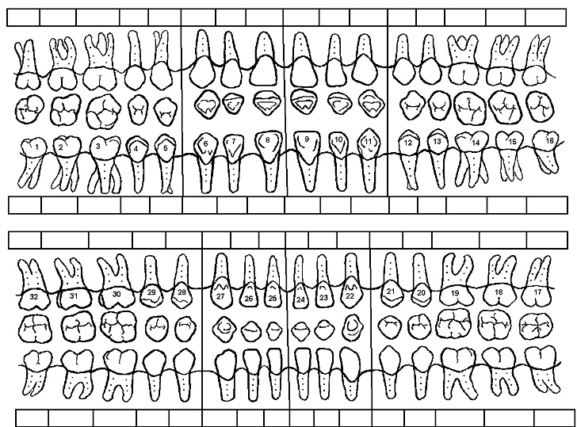Which two teeth have the most complex root system?
4. At what age will tooth #22 erupt in the mouth?
5. Show that tooth #30 has been removed.