**The Basics of Graphs**

Graphing is an important procedure used by scientists to display the data that is collected during a controlled experiment. When a graph is put together incorrectly, it detracts the reader from understanding what you are trying to present.

**Most graphs have 5 major parts:**

1. Title   
2. Independent Variable (X-axis)   
3. Dependent Variable (Y-axis)   
4. Scale for each variable   
5. Legend (or Key)

A. **Title**: Depicts what the graph is about. The Title gives the reader an understanding about the graph. A good title is closer to a sentence than a phrase and is usually found at the top of the graph.

B. **Independent Variable**: Variable controlled by the experimenter. The variable that “I” am testing. (I for Independent). Common independent variables include: time, generations, measurements (length, distance), and temperature. This variable goes on the X-axis.

C. **Dependent Variable:** Variable that is affected by the independent variable; what the experimenter measures. Example: How many oxygen bubbles will depend on the depth of the water. This variable goes on the Y-axis.

D. **Scale**: Before you can plot your data points, you must figure out how much each box on your graph paper is worth. Scale doesn’t’ always have to start at zero, but I must be consistent. If you start off making each box worth 5 cm, each subsequent box must also be 5 cm. Always make sure your scale is labeled with what it is and what the units are.

E. **Legend**: A short description about the graph’s data. Most often used to show what different patterns or colors stand for on your graph.

**Rules and Tips for Graphing:**

1. Always use a pencil to draw your graph. It’s easier to fix mistakes (Or use Excel!).

2. Always draw lines with a ruler. Do not freehand. Use at least half of your paper for the graph.

3. Make sure Independent Variable is on the X-axis and Dependent Variable is on the Yaxis.

4. Include all 5 parts above

***5. If you are graphing multiple subjects, use different colored or patterned lines and explain what they are in the legend.***

6. (ON NEXT PAGE)

6. Choose an appropriate graph to explain your data. Examples:

a. LINE: Measuring a change in something over time

b. BAR: Comparing individuals to each other with only one data point.

c. PIE: Show percentages that add up to 100%.

Questions: 1. The following graph is a fair to good example of a representation of data. Fill in the table with what is good about the graph and what could use improvement.

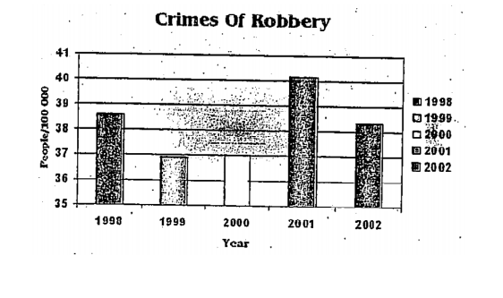

|  |  |
| --- | --- |
| Good | Needs Improvement |
|  |  |

2. The graph below is not a good graph. What parts are missing?

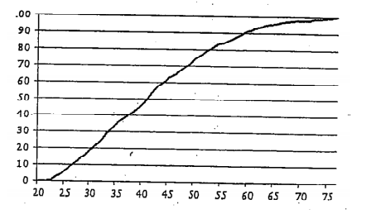

Experiment #1: Use the following information and data to create an appropriate graph and answer the questions. (graph paper on next page).

A marine biology student wants to see how well two different types of seaweed grow and in the shallow waters of the Bay of Fundy, Nova Scotia. These plants are rooted at various depths within the bay. The student wants to know what is the ideal depth for each plant to grow at. He will monitor the amount of Carbon dioxide bubbles produced by the plant as it goes through photosynthesis. This data was recorded in the chart below.

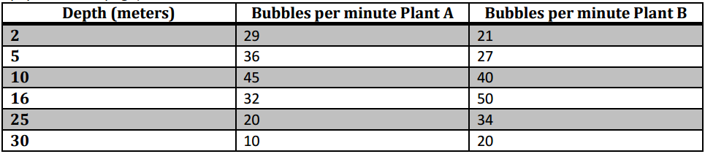

Answer the questions that follow and complete the graph on the next page.

3. What is the dependent variable? Why did you pick that answer? (GO BACK AND LOOK AT SCI METHOD NOTES!!!!)

4. What is the independent variable? Why did you pick that answer? (GO BACK AND LOOK AT SCI METHOD NOTES!!!!)

5. What would your scale be?

6. What title would you give this graph?

7. What information would you include in the legend of the graph?

8. What will you label the X-axis with? 9. What will you label the Y-axis with?

