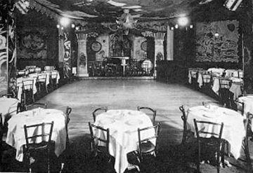

**Background:** The year is 1926. You and your partner have just purchused the Cotton Club, a swinging upscale jazz club located in Harlem. Your club has a national reputation as being one of the swingest new jazz clubs in the entire United States. Your nightclub is also a hotspot for the growing Harlem Renaissance; prominent African-American writers, singers, jazz musicians, and politicans love to hang out in your club. To celebrate your new ownership of the Cotton Club you and partner are planning a massive party where you will invite the most prominent members of the Harlem Renaissance.

**People:** You will need to invite each of the following guests to your club:

3 Writers

4 Jazz Musicians

2 Actors

2 Singers

1 Politician

2 Famous Gangsters (Do not have to be from the Harlem Rennassiance)

4 Sentence paragraph on how you plan to hide your illegal alcohol

**Assignment:**  Copy and paste a picture of each person you invited on the picture above. To move pictures around change the text wrapping feature. Below each individual create a textbox. Include each of the following in the textbox: Name, Category, Brief Description

Do not invite lame people to your club. Find people that you have an interest in.

**Assignment Criteria:** Due October 29th 5 points for neatness, 2 points for each guest (35 points total)

Handin method: Print a copy out and turn in or submit using the G-Drive